Biographies: Julia Kogan and Isabelle Aboulker

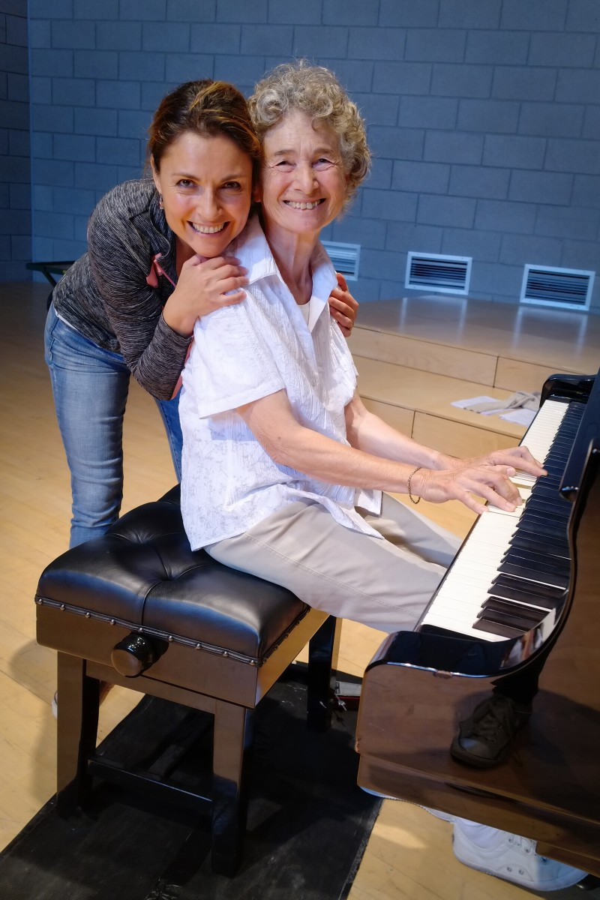
Julia Kogan is an award-winning American-French coloratura soprano, writer and presenter. She has performed in venues around the world, including multiple appearances at Carnegie Hall, the Lincoln Center, the Library of Congress in Washington D.C., as well as the operas houses of Aix-en-Provence, Toulouse, Toulon, Avignon, Limoges, Indiana, Winnipeg and many others across North and South America, Europe and Africa. Her work has been featured in numerous broadcasts on television and radio, as well as in the press (The New York Times, The Washington Post and Opera News). The Lost Songs of Hollywood, her BBC Radio 4 music feature about the unknown personal songs of the great European composers exiled in Los Angeles, was chosen ‘Pick of the Week’ by BBC radio. Julia is also an author of children’s books and the feature film Florence Foster Jenkins, which she co-authored. Her discography of solo recordings includes Vivaldi Fioritura with Chamber Orchestra Kremlin, Troika: Russia’s westerly poetry in three orchestral song cycles with the St Petersburg Chamber Philharmonic and In Jest: comic art songs from baroque to contemporary with pianist Tyson Deaton, a FHR release.

Isabelle Aboulker was born in 1938 under the concordant influences of a grandfather composer, Henry Février, and a father, Marcel Aboulker, who was both a film director and writer. In parallel with her studies in music theory and accompaniment at the Paris Conservatory, she composed for the cinema, the theatre and television. An accompanist, a choral director and subsequently teacher of singers at the Paris Conservatory, she focussed her creative activity from 1981 on the voice and opera. Attentive to prosody, demanding in the choice of libretti, she considers herself an heir to the French tradition of Debussy, Ravel and Poulenc. The success of her first stage work Les Surprises de l’Enfer (1981) revealed her orientation: Leçons de français aux étudiants américains (1983), Trois folies d’opéra pour trois femmes compositeurs (1986), Cinq Nô Modernes (1992), La Lacune(1993), Monsieur Balzac fait son théâtre (1999), Le Renard à l’opéra (2004). Isabelle Aboulker is no less renowned for her operas for children. From Moi, Ulysse (1982, commissioned by Jean-Claude Malgoire for the Atelier Lyrique de Tourcoing) to Jérémy Fisher (2007, commissioned by the Debussy Quartet and Lyons Opera), her works Atchafalaya, Martin Squelette, Douce et Barbe Bleue, La Fontaine et le Corbeau, Les Fables Enchantées, Les Enfants du Levant are frequently performed by conservatories and music schools, and they regularly appear in the youth programmes of the major French and foreign opera houses. Douce et Barbe Bleue and Les Fables Enchantées have been released as book-CDs by Gallimard Jeunesse. Isabelle Aboulker has also composed, in the collection ‘Écoutez-lire’, several scores that accompany Le Petit Prince, Inconnu à cette adresse, L’Ami retrouvé. In 1999 she was awarded a prize by the Académie des Beaux-Arts and in 2000 received the SACD music prize.

